**Nominal Ledger**

**Index**

**Nominal Ledger................................................................................................................. 1 - 60**

**Enquiry.................................................................................................................................... 1 - 11**

**Nominal Code Type Search................................................................................................. 5**

**Open Item Type Search ..................................................................................................... 7**

**Reference Type Search ...................................................................................................... 9**

**Run Number Type Search ................................................................................................ 10**

**Stock Number Type Search............................................................................................... 11**

**Journal Entry ......................................................................................................................... 12 - 32**

**Standard Journal ............................................................................................................. 12**

**Reversing Journal ............................................................................................................ 13**

**Automatic Journal ........................................................................................................... 14**

**Standard ............................................................................................................. 14**

**Balance Re-Allocation.......................................................................................... 15**

**Contra Journals ............................................................................................................... 18**

**Import Transactions ........................................................................................................ 24**

**Intercompany Journal ..................................................................................................... 26**

**Adjustment Journal ......................................................................................................... 28**

**Open Item Processing ...................................................................................................... 29**

**Update ........................................................................................................................................ 31**

**Nominal Ledger**

**Enquiry**

To access the Nominal Ledger > Enquiry, select from the main menu.

This gives the ability to search for specific transactions based on the type of Nominal Code, Open Item, Reference, Run Number and Stock Number

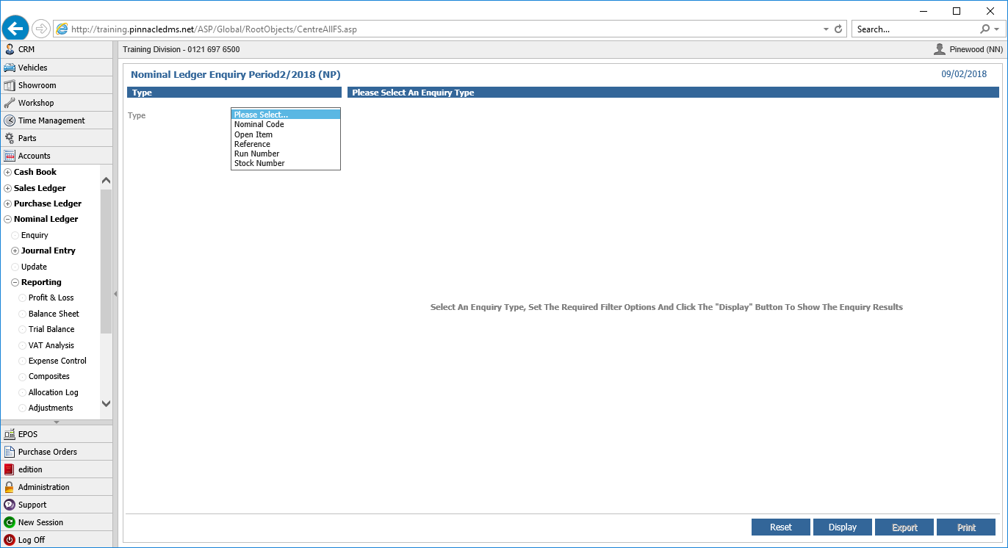

This can be filtered further by the source of the transaction, such as Vehicles, Parts, Workshop departments etc.

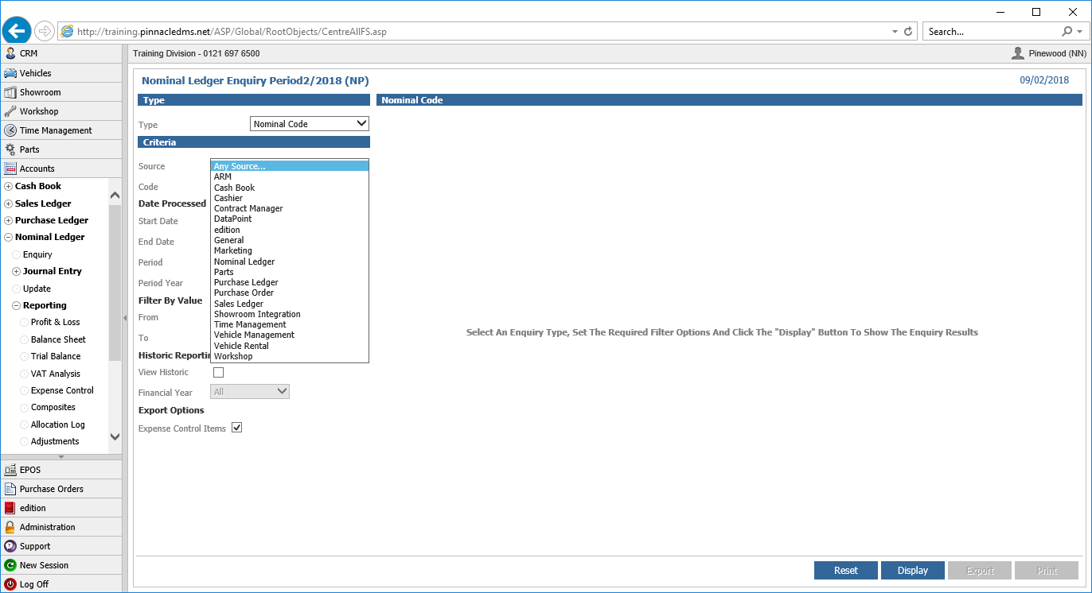

Date criteria or specific posting periods can also be entered to limit the search fields further.

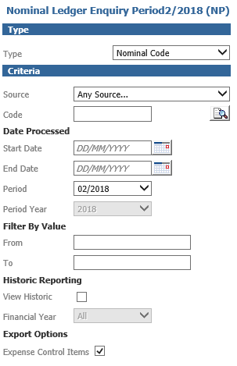

The value can also be used to find a specific transaction such as invoices at zero value, values between £1000 and £1500 etc.

Historic Reporting will allow enquiries on transactions for previous financial years.

Depending on the ‘Type’ that has been entered, enter either the nominal code, open item, reference, run number or stock number for enquiry. Select ‘Display to see the results.

**Nominal Code Type Search**

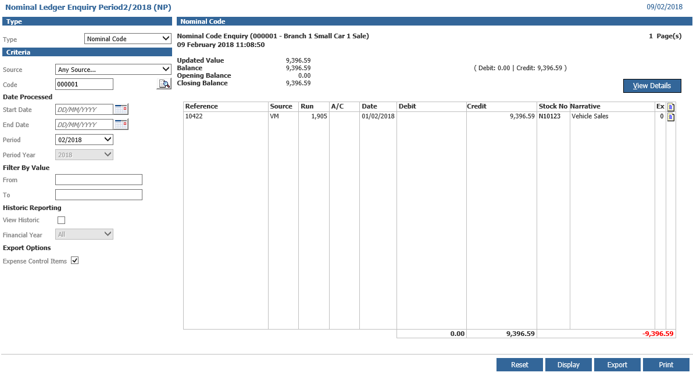

On the results screen, if enquiring across a single period, the balance at the start and the end of the period as well as the updated value and balance are shown at the top of the screen. Where the enquiry is across a financial year, the values will be as per the opening value of the start period and the closing value of the last period for a balance sheet account and the YTD figure for a profit and loss account. Click ‘View Details’ to see the individual transactions on the nominal code. Double click on any column for the selected transaction, apart from the A/C or Stock Number column and this will display the transaction detail including the user, company, department, source, date and run.

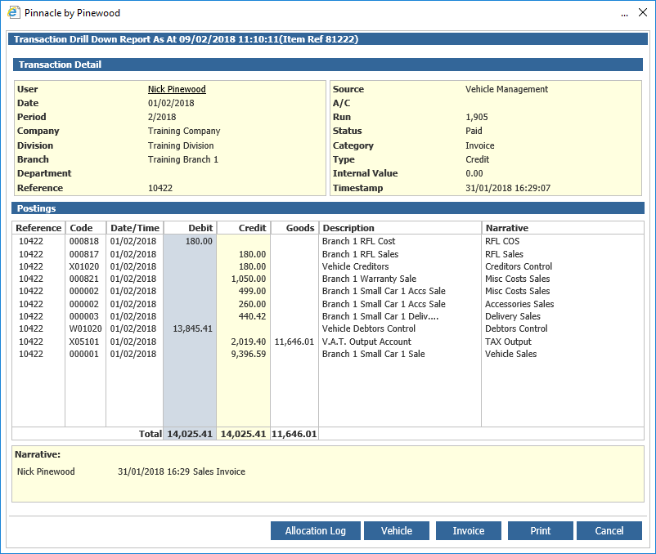

The corresponding entries of the posting will also be shown. Click ‘Vehicle’ to go to the stock card, ‘Invoice’ to see a copy of the invoice which can be printed or emailed, ‘Print’ to print a copy of the drill down or ‘Cancel’ to return to the enquiry results screen. The ‘Allocation Log’ will allow a search to show when this transaction was paid and allocated.

If the transaction on the enquiry result screen relates to a sales or purchase ledger account, click on the ‘A/C’ column to view the sales or purchase ledger account enquiry screen.

If the transaction relates to a vehicle record, click on the ‘Stock No.’ column to view the vehicle stock card.

By selecting the page icon at the end of the transaction line, an archived invoice can be viewed, printed or emailed.

Choose the ‘Export’ option to download the postings into a spread sheet format.

‘Print’ will print the enquiry screen displayed. ‘Reset’ will blank out the nominal code field in the search criteria screen to enable a new search to be done.

**Open Item Type**

Search Open items allow for ‘Schedule’ accounts to be created for Balance Sheet nominal codes. The enquiry screen allows a search by open item ‘Reference’ or by nominal code range

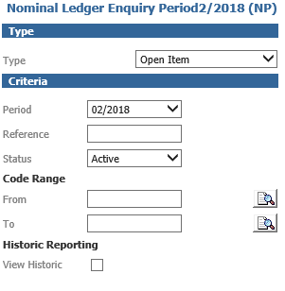

Enter a reference to show the balances within the open item nominal codes for that reference and click ‘Display’.

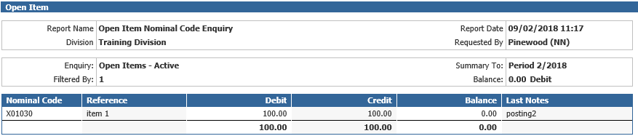

Double click on the reference line to see the individual transactions that make up the balances for that reference.

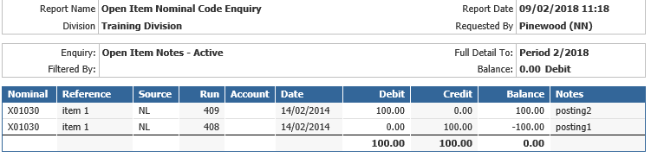

Double click on a transaction line to drill down into the posting detail.

In the Nominal Ledger Enquiry screen, enter a nominal code range to see the references against each open item nominal code.

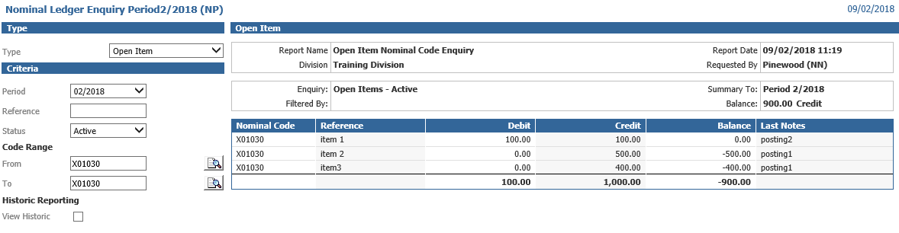

Again, double click on the reference line to see the individual transactions that make up the balances for that reference then double click on a transaction line to drill down into the posting detail.

**Reference Type Search**

Select the search type as ‘Reference’. The reference can be an invoice number (sales ledger or purchase ledger), a cheque number, a cashbook receipt reference or any text entered in a reference field when posting transactions.

A specific source of transaction, reference, date range, accounting period or any combination of these search criteria can be searched on. Click ‘Display’ to see the search results.

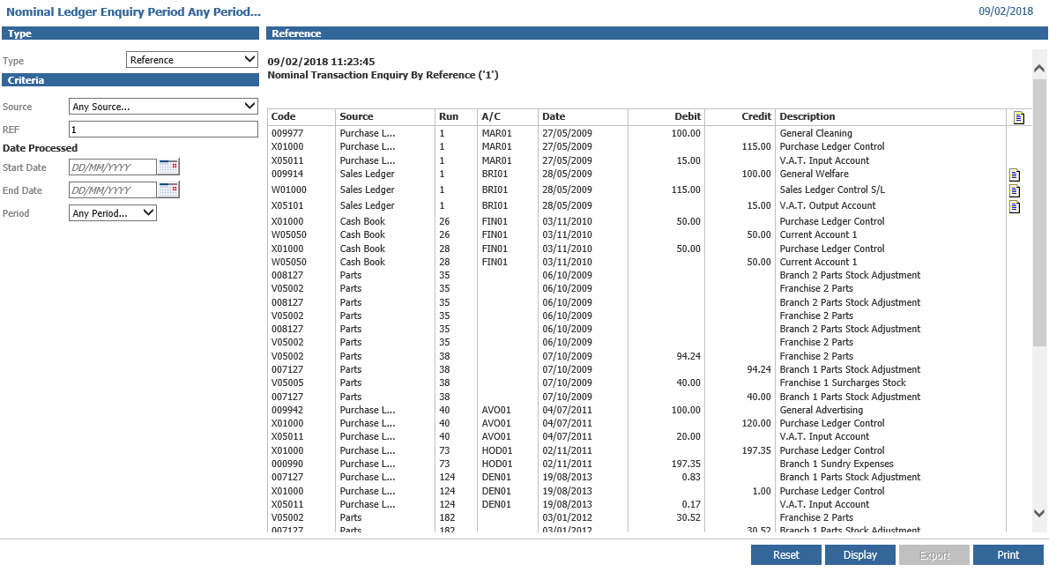

The nominal postings display for the reference. A copy invoice can be printed or emailed out. Double click on a nominal posting to see the transaction drill down report.

**Run Number**

Type Search Select the search type as ‘Run Number’. A specific source of transaction or person who created the transaction can be selected. A date range, run number range and accounting period can also be used as search criteria. Click display to see the search results. Click on the + sign to view the nominal ledger postings within the run.

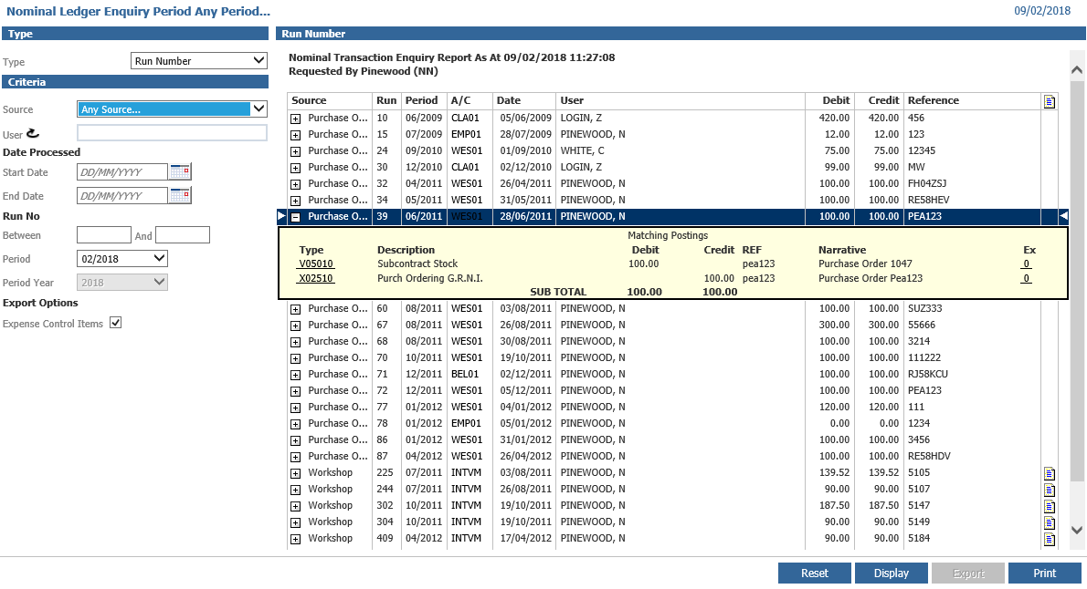

Double click on the postings detail box to see the transaction drill down report.

Returning to the main run number enquiry screen, click on the sales ledger or purchase ledger account numbers to see the account enquiry screen within the relevant ledger. Click on the invoice icon at the right hand side of the screen to see an invoice copy. This can be printed or emailed.

If the run number relates to a cashbook receipt posting, double click on the reference number to display the Cashbook Extended Detail report.

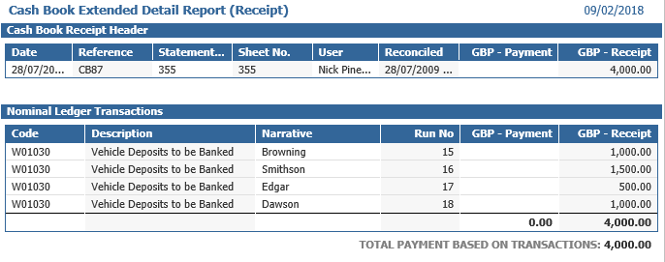

**Stock Number Type Search**

In the search criteria screen, select the search type as ‘Stock Number’, select a Branch and click on the search icon to select a stock number. Click ‘Display’ to see all the nominal ledger transactions for the stock record.

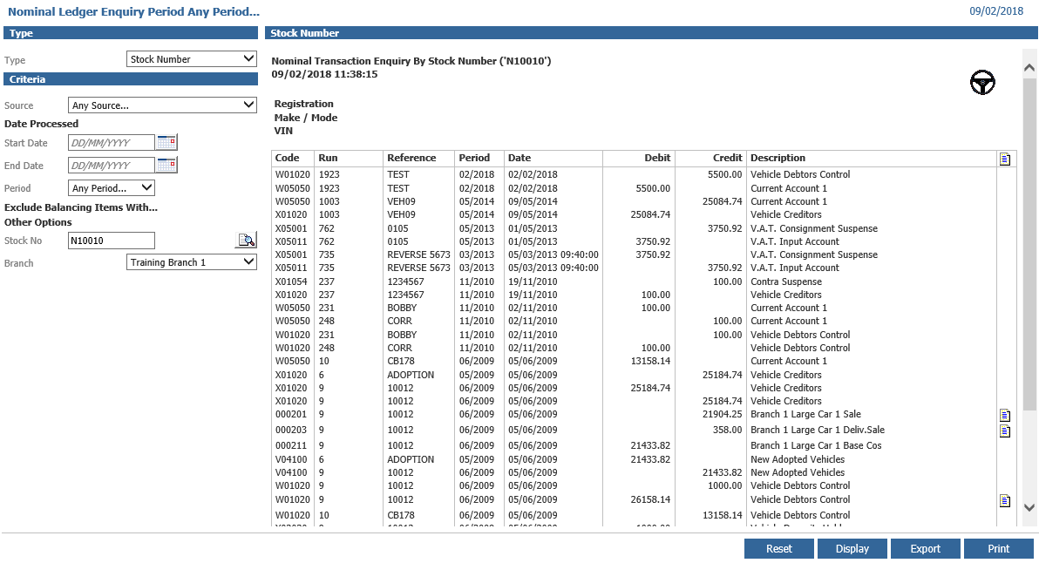

Select the steering wheel icon in the top right hand corner to view the Vehicle Stock Card. The ‘Reset’, ‘Export’ and ‘Print’ buttons work as previously explained.

**Journal Entry**

The nominal ledger follows the principle of double entry book keeping in which any postings affecting the business are recorded as a transaction with a movement of an amount from one code to another within the nominal ledger. This ensures that any debit movement must also have a credit movement of equal value.

Accounting activity that is not recorded by the other integrated modules is posted to the system as a journal entry.

**Standard Journal**

Select the ‘Journal’ option from the main menu.

Input a date within the selected accounting period and a posting reference for the journal.

Click ‘Next’ to continue.

Enter the nominal code for the posting or use the icon to search for the correct nominal code. Enter the amount in either the debit or the credit column. Any narrative entered can be viewed against a code at a later date (by selecting the ‘=’ sign any narrative on a previous line on this journal can be copied down).

Where a posting is made to a Tax account, an appropriate goods value must be entered into the goods column.

If the posting relates to a sales vehicle, select the correct stock number to which the transaction will be linked.

Select ‘Add’ and continue creating the posting lines.

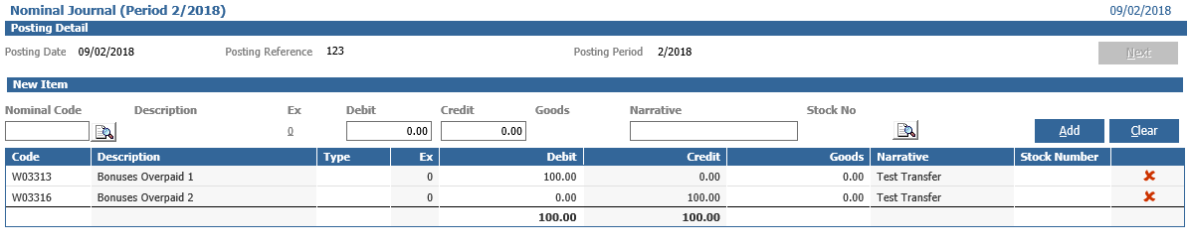

Only when the journal is in balance can the journal be posted by clicking on ‘Complete’. This will produce a Nominal Journal Daybook which should be printed and filed.

**Reversing Journal**

Select the ‘Reversing Journal’ option from the main menu.

These are entered in exactly the same way as journal entries, however reversing journals are immediately reversed in the following accounting period. The posting period and reversal period are shown in the top right hand corner of the posting detail screen.

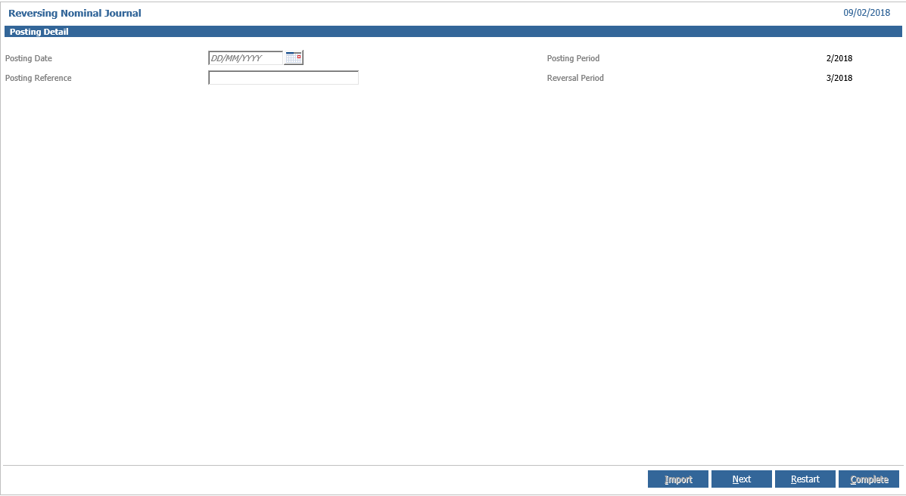

Only when the journal is in balance can the journal be posted by clicking on ‘Complete’. This will produce a Nominal Journal Daybook which should be printed and filed.

**Automatic Journal**

**Standard**

Where the same journal is to be posted each month, an Automatic Journal may be created. Select the ‘Automatic Journal’ option from the main menu.

Any Automatic Journals that have already been created and saved will be listed on the left hand side of the screen.

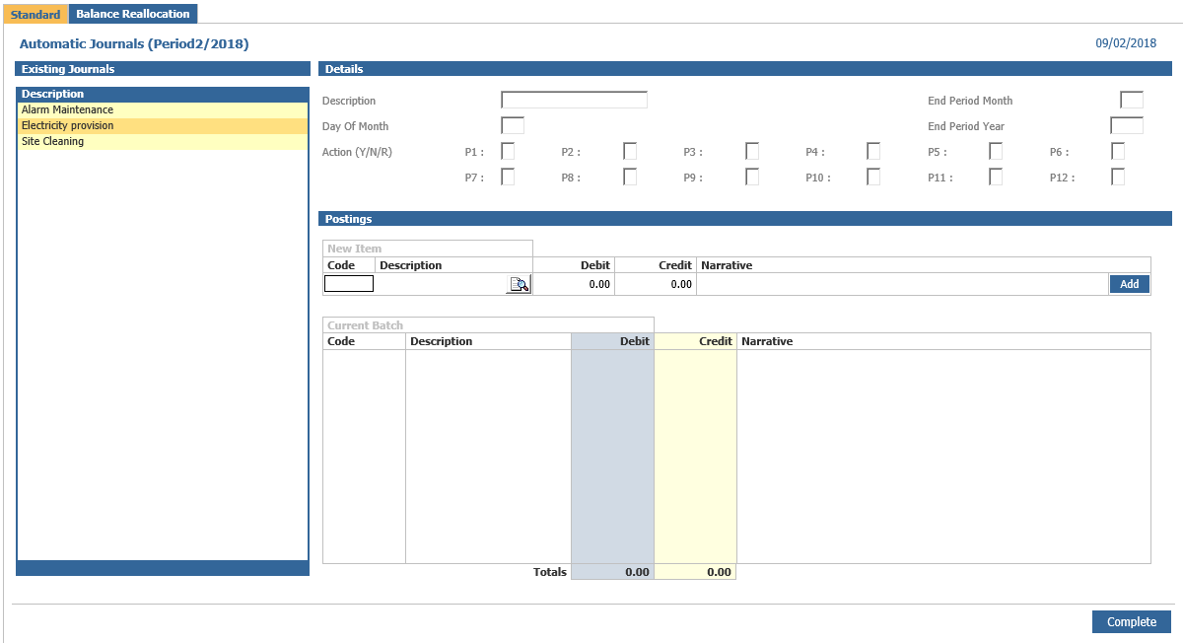

Enter the description of the new journal to be created and the day of the month that the journal should be processed. Each period within the financial year requires an entry of Y, N or R. Y = post the journal into the period as entered, N = do not post the journal for the period and R = post the journal with the debits and credits reversed for the period.

Enter the End Period Month and Year to identify when the processing of the automatic journal is to stop.

Enter the nominal code or click to use the search option to find the nominal code. Enter the amount to be debited or credited to the code. A narrative may also be entered which appears against the posting to the nominal code. Select ‘Add’ and repeat the process until all codes have been selected. Once the journal is in balance, click on ‘Complete’ to save the detail.

Automatic journals are posted when the nominal ledger is updated after the day of the month specified within the automatic journal details.

Where an existing automatic journal is to be amended or deleted, double click on the description and select either ‘Amend’ or ‘Delete’ as appropriate.

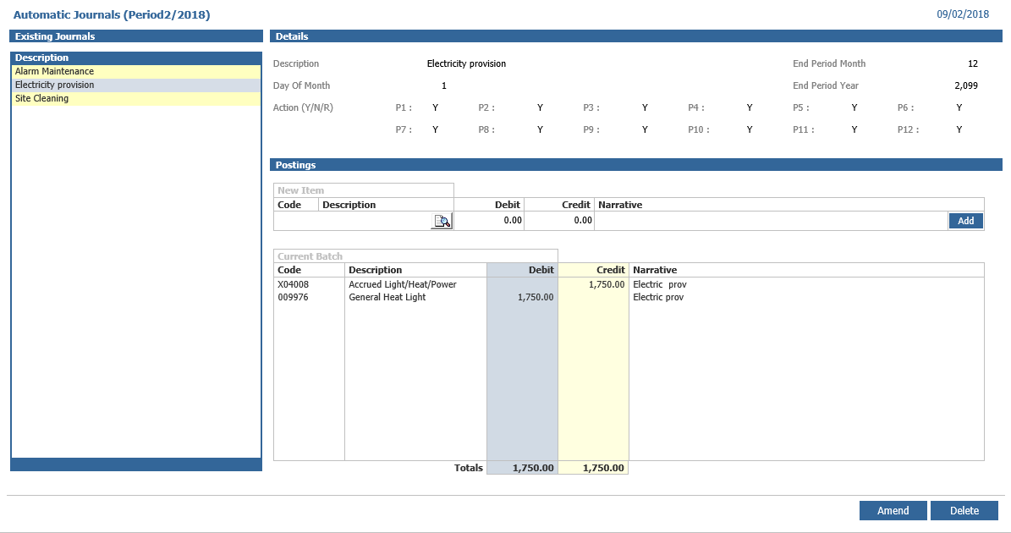

**Balance Re-Allocation**

Pinnacle will now allow you to create and amend reallocation journals through a csv file, this gives you the opportunity to upload a file with all the data of your reallocation journals.

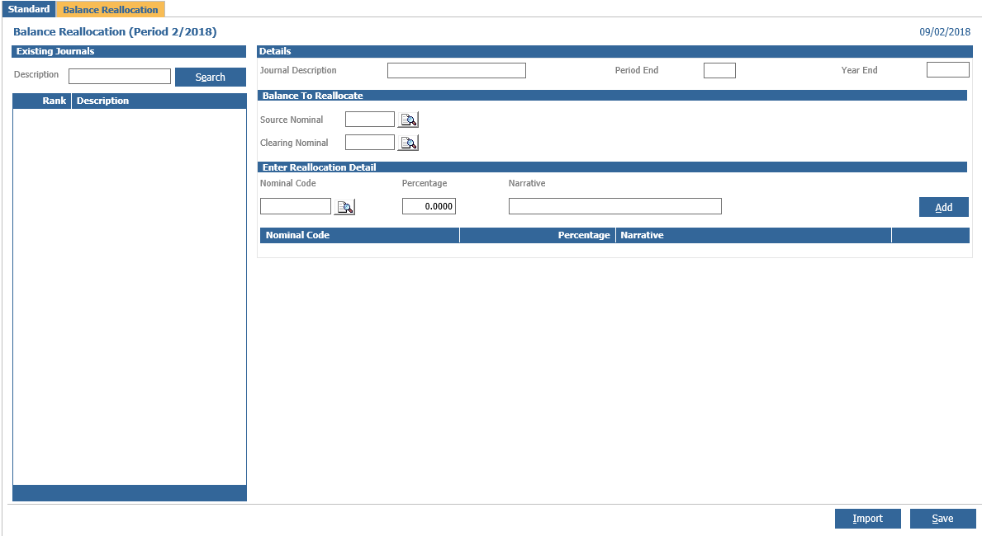

Upon clicking the button, you will be faced with the below setup. Here you can Browse the file you wish to upload to Pinnacle with your data in

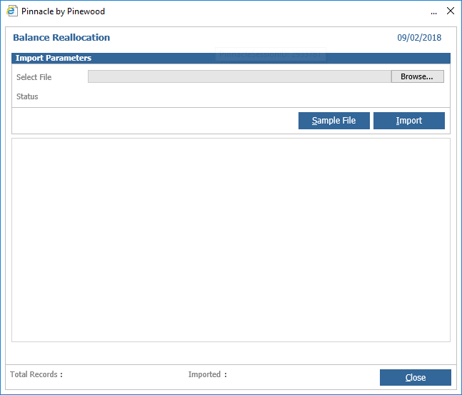

Looking at a sample file below, this can be downloaded to provide a basis for the format of the file you need to upload

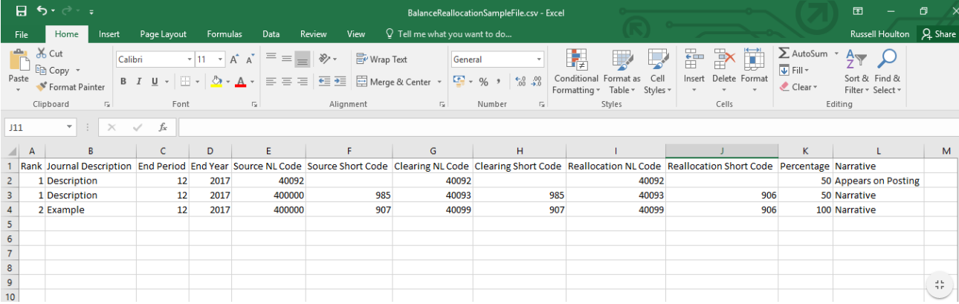

**Rank** - This dictates the order that the journals will be run within Pinnacle. Rows within the spreadsheet can have the same rank if they relate to the same Journal. Or this column can be left blank and the order will be dictated by the order in which the journals appear in this file.

**Journal Description** – This will name the journal and dictate which rows are grouped together by the names that match through the file. In the example above, you can see the first two rows are part of the same journal.

**End Period** – The last period in which the journal will be run as part of the nominal ledger update routine.

**End Year** – Set with the End Period to determine when this journal will no longer run as part of the nominal ledger update routine.

**Source NL Code** – This will dictate the source nominal code to reallocate from. If this is not entered as a 6 figure format, it will populate 0s at the beginning of the code.

**Source Short Code** – Here you can enter a short code for this nominal, if this function is turned on within your Pinnacle

**Clearing NL Code** - This will dictate the clearing nominal code. If this is not entered as a 6 figure format, it will populate 0s at the beginning of the code.

**Clearing Short Code** - Here you can enter a short code for this nominal, if this function is turned on within your Pinnacle

**Reallocation NL Code** - This will dictate the source nominal code to reallocate to. If this is not entered as a 6 figure format, it will populate 0s at the beginning of the code. This could be reallocated to more than one nominal, so multiple rows can be added to include different nominal codes to split the reallocation across.

**Reallocation Short Code** - Here you can enter a short code for these nominal codes, if this function is turned on within your Pinnacle

**Percentage** – This can be used to split reallocation across multiple nominal codes. The overall total for each journal must add up to 100% or else it will not import.

**Narrative** – Here you can enter any text required to post with this nominal.

Once you have created your file, you will simply need to browse and select it to be imported.



This screen will display the total number of rows in the file you have selected, rather than the total number of reallocation journals within this file.

Any errors with your upload will also be detailed in this screen when you upload it to Pinnacle. However, if one row does have an issue, the process will continue to upload the rest of the data, meaning you will only have to go back and amend the single entry that gave you feedback on why it was unsuccessful. It will not fail the entire file.

Upon closing this window, Pinnacle will refresh and display all the successfully loaded files on the left hand side under ‘Existing Journals’. Here these can be individually selected and details looked at.

Existing files can be updated if any detail of a journal ever need amending. As long as the name of the file being uploaded, and the Journal Description remains the same, Pinnacle will update and overwrite existing details with your new data, rather than duplicate entries.

**Contra Journals**

Contras may be used to post matching debit and credit values into the four ledgers, i.e.; Sales Ledger, Purchase Ledger, Vehicle Ledger and Nominal Ledger. The two ledgers to be used within each contra must be open in the accounting period that the contra is to be processed in.

The contra is split into four sections.

The 1st section is the contra details.

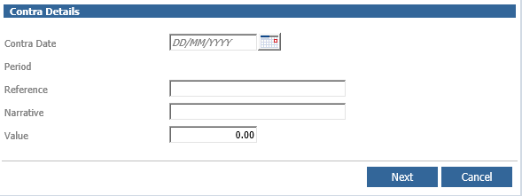

Enter the transaction date and the accounting period for that date, which will appear as long as the accounting period is still open. Enter a reference, a narrative for further information and the value of the contra. Click ‘Next’ to continue.

The 2nd section is where the ledgers to be affected by the contra are selected.

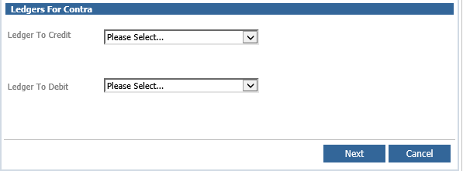

From the dropdown boxes, select the ledger to be credited and the ledger to be debited. Click ‘Next’ to continue.

If the Nominal Ledger is selected, a pop up box will appear.

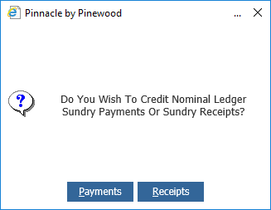

Select the required option of Payments or Receipts, this dictates input or output VAT, if VAT is not included then no value will be entered and either can be selected.

If the Vehicle Management Ledger is selected, a different pop up box will appear.

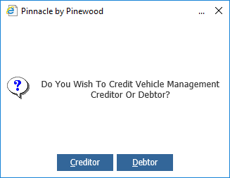

Select the required option depending on whether you want this debit posting to appear on the Vehicle Creditor or Vehicle Debtor.

The 3rd Section is the Credit Posting Section.

As the option to Credit Nominal Ledger Receipts was taken above, the following screen appears.

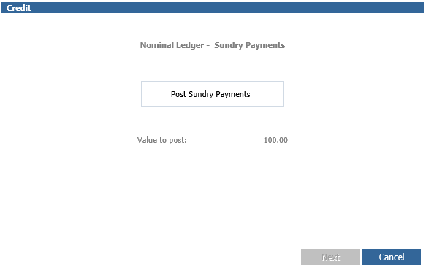

Click on the ‘Post Sundry Receipts’ box in the centre of the screen and the nominal posting screen appears.

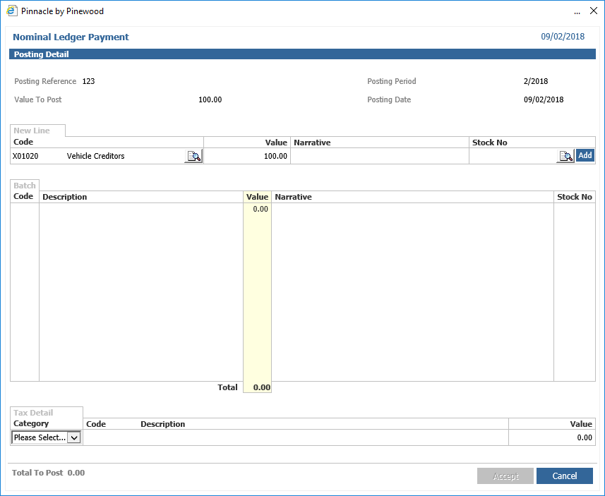

Enter the nominal code, value and narrative to be posted and click ‘Add’ at the end of the posting line. Repeat this until the total value has been analysed then click ‘Accept’. The tax category can be selected and a VAT value entered at the bottom if required. On the main screen click ‘Next’ and a journal print will appear as a preview. This can be printed. A reprint is available if required.

The 5th Section is the Debit posting section.

As the option to Debit Vehicle Creditors was selected above, the following screen appears

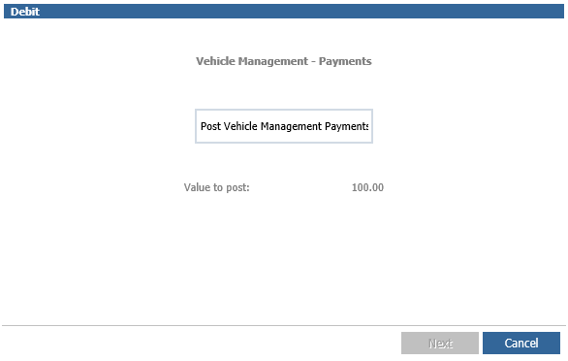

Click on the ‘Post Vehicle Management Payments’ box in the centre of the screen.

Search for the required vehicle using the Customer Name, Stock Number, Reg Number, Order Number or Vin Number.

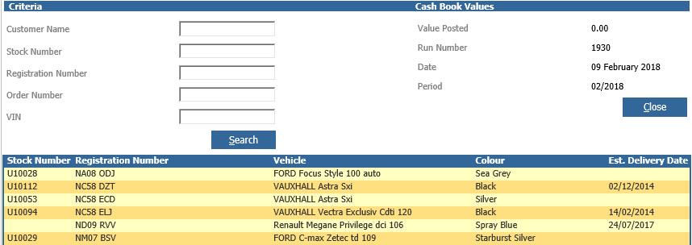

Double click on the required vehicle and depending on whether Receipts or Payments were chosen the vehicle debtor or creditor page for that vehicle appears.

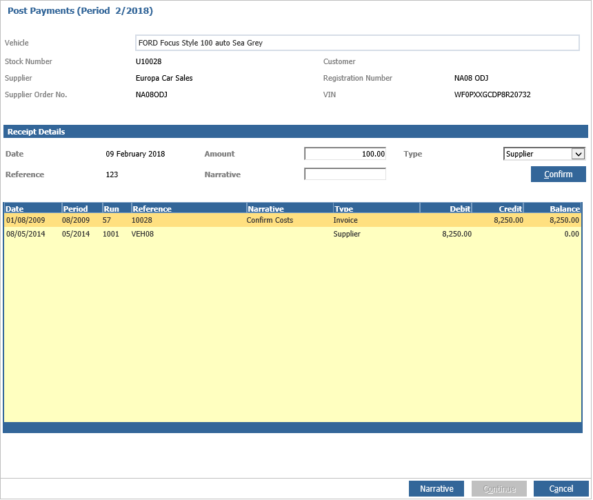

Click ‘Confirm’ to post the value to the bottom of the screen and affect the total balance and click continue.

Note: If a Credit to Vehicle Management Creditors is selected, the posting screen will display as a Type – Refund in the right hand side of the screen and will display the Vehicle Debtor page but when ‘confirm’ is clicked, will correctly post to the Vehicle Creditor page which is in the background and not displayed.

If a Debit to Vehicle Management Debtors is selected, the posting screen will display as a Type – Customer Refund in the right hand side of the screen and will display the Vehicle Creditor page but when clicking ‘confirm’, will post correctly to the Vehicle Debtor page which is in the background and not displayed.

Click ‘Next’ to complete the contra and a vehicle daybook prompt appears. This daybook may be printed if required.

If a sales ledger or purchase ledger has been chosen to be credited or debited instead of Vehicle Management or Nominal Ledgers, click in the ‘Account Code’ box to enter or search for the required account.

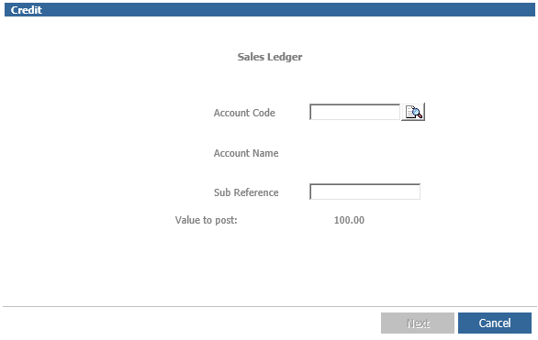

Click ‘Next’ to continue. A daybook may be printed if required.

IMPORTANT: - If the ‘Cancel’ option is taken halfway through the posting; the contra nominal code should be checked as only one side of the contra may have completed with the other side posting to Contra Suspense nominal code. This will need to be journalled or contra’d out of this code and posted to the correct account, as this should be a zero balance account.

**Import Transactions**

Sales or Purchase Ledger transactions may be imported in bulk using this process.

A .csv file will be created with the transaction details in the following format:-

**Sales Ledger**

|  |  |  |  |  |  |  |
| --- | --- | --- | --- | --- | --- | --- |
| **Spread-sheet Column** | **Pinnacle Field Name** | **Max Length** | **Notes** | **Format** | **Mandatory** | **Example** |
|  |  |  |  |  |  |  |
| **A** | Account Code | 5 | **Unique identifier** | Alphanumeric | **Y** | "FOR01" |
| **B** | Type | 3 | Inv/Cr | Alphanumeric | **Y** | "Inv" |
| **C** | Reference | 20 | Old invoice number | Alphanumeric | **Y** | "W878768" |
| **D** | Date | 10 | dd/mm/yyy | Date | **Y** | "30/12/2007" |
| **E** | Transaction value |  | £.pp | Decimal | **Y** | "545.76" |
| **F** | VAT Amount |  | When blank no VAT posting will be created | Decimal | **N** | "25.00" |
| **G** | Sub reference | 20 | Generic Reference | Alphanumeric | **N** | "DJ12DAJ" |
| **H** | Nominal Code | 6 | Will take precedent over the default entered on the import screen | Alphanumeric | **N** | "0X0001" |

**Purchase Ledger**

|  |  |  |  |  |  |  |
| --- | --- | --- | --- | --- | --- | --- |
| **Spread-sheet Column** | **Pinnacle Field Name** | **Max Length** | **Notes** | **Format** | **Mandatory** | **Example** |
|  |  |  |  |  |  |  |
| **A** | Account Code | 5 | **Unique identifier** | Alphabetical | **Y** | "FOR01" |
| **B** | Type | 3 | Inv/Cr | Date | **Y** | "Inv" |
| **C** | Reference | 20 |  | Alphanumeric | **Y** | "W878768" |
| **D** | Date | 10 | dd/mm/yyy | Decimal | **Y** | "30/12/2007" |
| **E** | Transaction value |  | £.pp | Decimal | **Y** | "545.76" |
| **F** | Supplier reference | 20 |  | Alphanumeric | **Y** | "TOWBAR3241" |

Select the ‘Import Transactions’ option from the main menu.

The upload screen will appear.

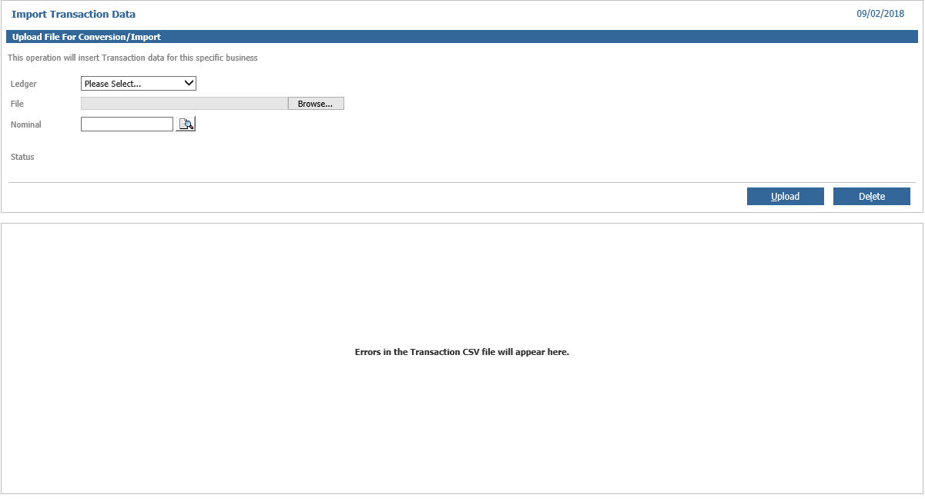

Select the ledger to be uploaded and then click on the ‘Browse’ button to pick up the .csv file created. Enter a nominal code for the opposite posting to post to and click ‘Upload’. Any errors will appear in the bottom half of the screen.

If the import is successful, the status will change to ‘Data Conversion Complete’.

**Intercompany Journal**

The intercompany journals are created in a similar way to standard journals.

Select Accounts > Nominal Ledger > Journal Entry > Intercompany Journal from the menu.

The initial screen is the same as a standard journal. Ensure that the correct period is being displayed on the right hand side and enter the date and the posting reference.

Click ‘Accept’ at the bottom of the screen to continue with the journal. This will display a screen similar to a standard journal screen but with some slight changes. The first stage is to select the division to journal from. The new Division field will display all Divisions that have a control code assigned in the parameters.

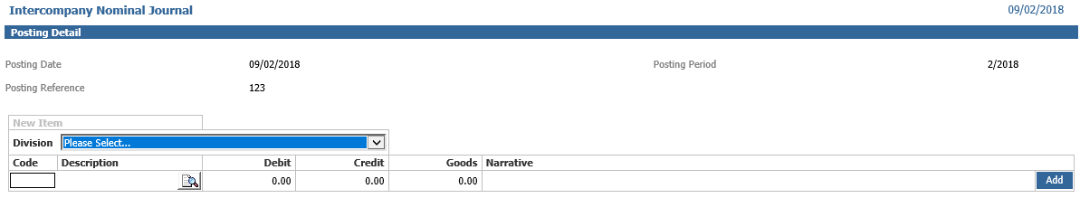

If the control codes have not been correctly allocated and activated in the divisions, a message advising this will be displayed. Check the set up within Nominal Ledger Parameters.

Once the correct division is showing, add the code, Debit/Credit and Narrative for the posting. For the division that is currently being worked in, ALL nominal codes are available, not just the ones specified on the Intercompany Journal Codes parameters. Complete all the information and ‘Add’ the line.

Then choose the division that the journal is going to. If the division to be journalled to does not have the current period open, a message will be displayed and the journal cannot continue.

Once the correct division is showing, add the code and Narrative for the posting. The only codes that are available in this section are the ranges added in the Intercompany Journal Codes parameters for the person posting the journal.

The completed journal will need to balance and the new screen displays the Divisions in which the journals have taken place

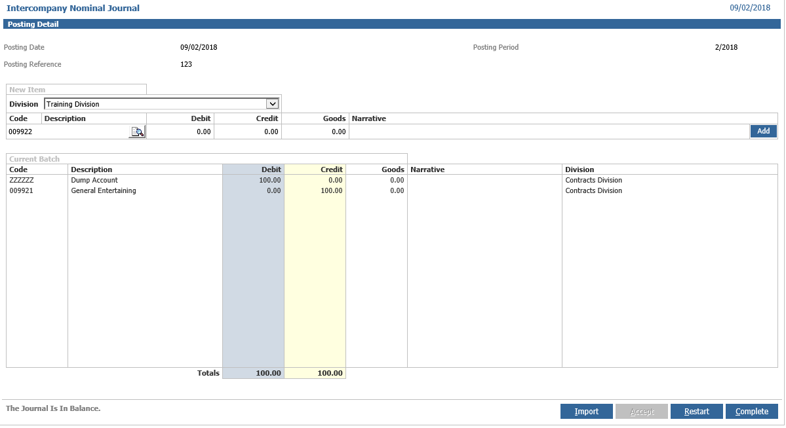

Once all the journal postings are finished (multiple transactions can be completed to different Divisions in the same Journal, if required), click the ‘Complete’ button to complete the journal. The system produces an Intercompany Nominal Journal Day Book outlining all the transactions completed in the journal. Where the journal screen only shows the items manually added, the Day Book will show the double-entry transaction including the control codes.

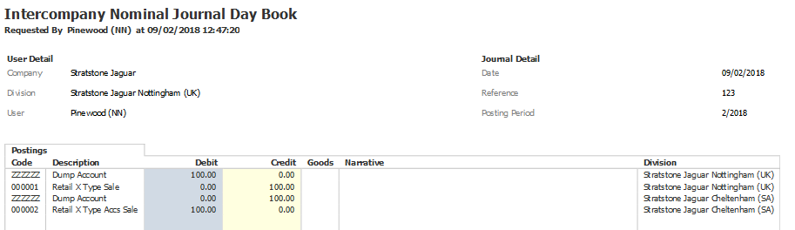

This process will leave a balance on both the control nominals for the originating Division and the destination Division that will need to be dealt with accordingly.

Notes:

1. Open Item and Fixed Asset nominal codes cannot be selected.

2. Divisions without a control code will not be available for intercompany journals.

3. The current period being worked in must be open in each division the user is journaling to.

4. All codes can be selected in the division the user is working in (except fixed asset or open item codes), for other divisions, only the codes set in the Intercompany Journal Codes screen can be used

**Adjustment Journal**

The nominal ledger Adjustment Journal function allows for journal postings to be made to closed periods. This is created by taking the same steps as a normal journal with the addition of selecting the period the journal is to be posted to. This feature should only be used by people familiar with the issues involved with posting to prior periods.

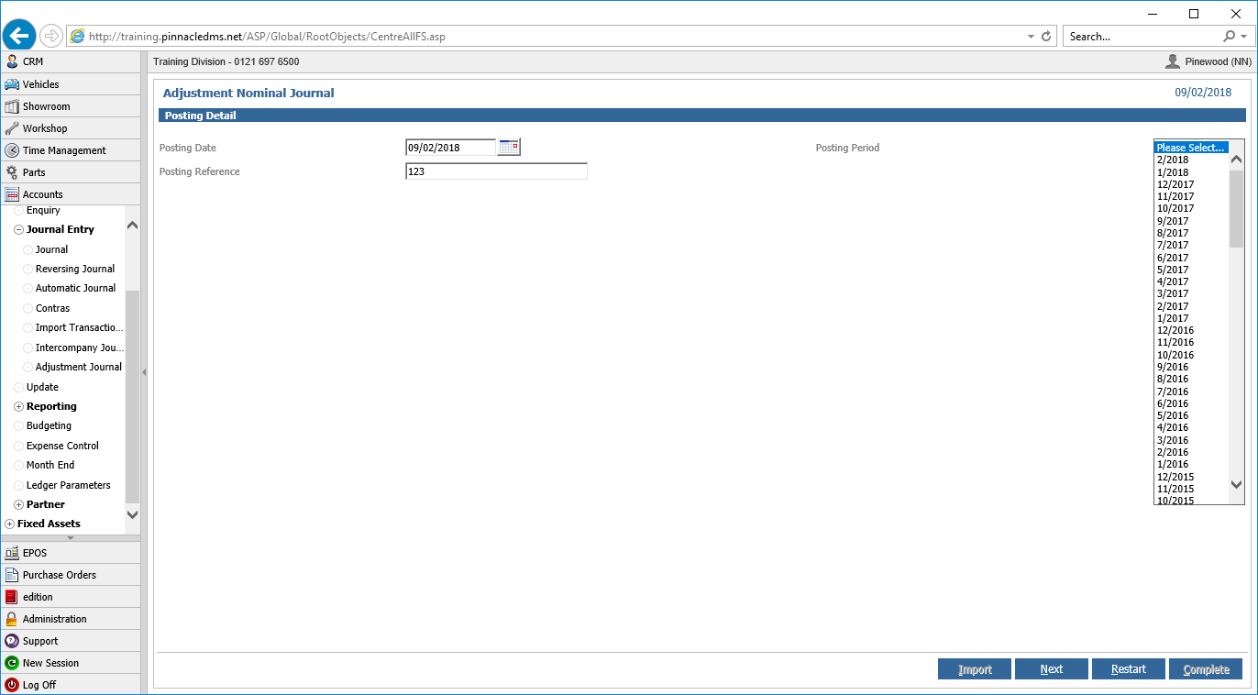

On completion of the journal, a daybook printout will be produced with the period value showing as the selected period.

Any journal into a closed period that includes a posting to a Profit & Loss nominal code will affect the profit that must be transferred to the Balance Sheet each month. To avoid putting the ledger out of balance, any journal adjusting the P&L profit should also include a posting to the transfer nominal code for the balance of the adjustment to retained profit. A warning will be presented as a reminder if any P&L codes have been selected, regardless of whether the transfer posting has been included. It will not be displayed if the postings only relate to the Balance Sheet or if the P&L impact of the postings is Zero.

An Adjustments Report detailing all adjustment journals posted within the specified period is available within the Nominal Ledger Reporting menu.

**Open Item Processing**

**Posting to an Open Item Nominal Code**

Whenever an open item nominal code is selected, an open item note will be processed and linked to the nominal transaction.

After creating and completing a posting the open item functionality will be instigated. Validation will take place against each line of the posting to determine whether the nominal code defined is set to open item. The open item pop-ups will appear when the nominal code for a transaction is set to open item.

The new open item processing screen allows for one posting to be taken but create and update multiple open items in one popup, thus reducing the time taken to process open items. The popup is available in all processes where Open Item functionality is available. This includes Cash Book Receipts and Payments, Purchase Ledger Invoices, Sales Ledger Invoices, Nominal Ledger Journals, Automatic Journals, Reversing Journals and Contras.

Using a Nominal Ledger Journal as an example, where debiting an open item code by £10,000.00 and six new open items are created; five for £1,000.00 each and one for £5,000.00. The process requires only one journal line (with its balancing posting) and then a single open item popup.

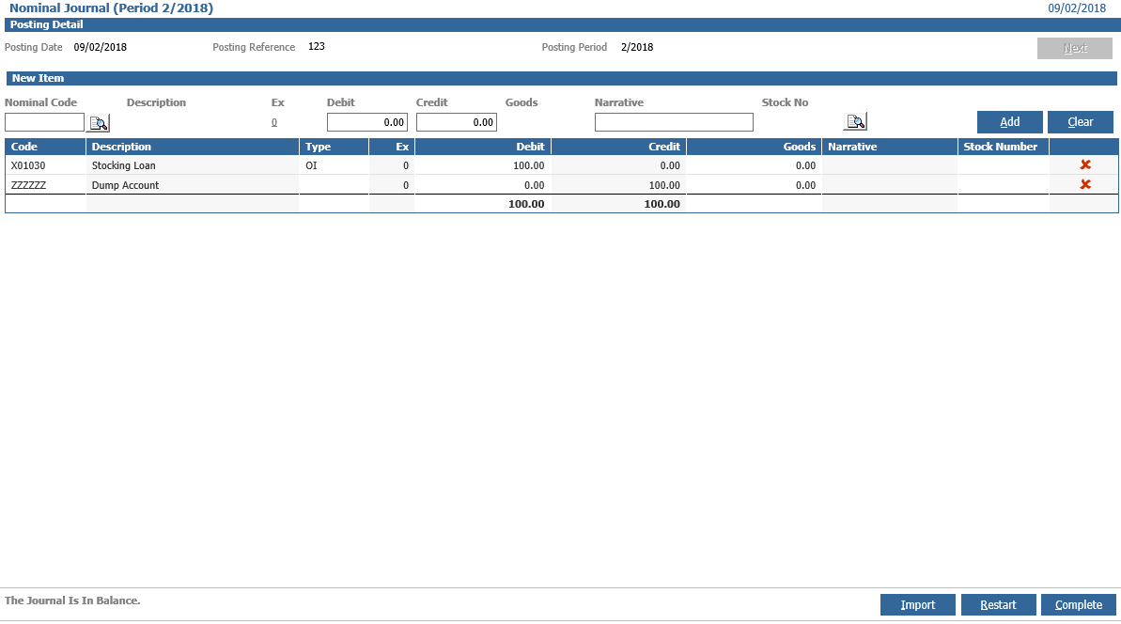

On completion of the journal the new open item popup will be loaded. The popup is split into three sections, an ‘Open Item Details’ section showing details of the posting to be completed, the ‘New Open Item’ section where new items can be created and the ‘Existing Open Items’ section where updates can be completed.

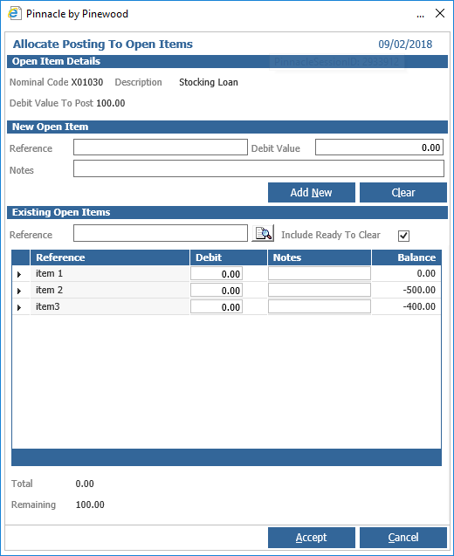

In the example above the six items have been added using the new open items section and the running total and remaining value area also presented, and in the existing open item section the reference filter criteria and arrow symbol which will clear the balance on the open item. When the popup is completed the new open items will be created and the 10,000.00 posting will be split out into six individual postings with corresponding amounts, the printed daybook will also reflect this.

Open items can be viewed in the nominal ledger enquiry routine. See Nominal Ledger Enquiry section for further details

**Update**

The Update option should be used after a journal or transaction import or to process an automatic journal with a posting date prior to the date it was initially created. It is also advisable to use the update option before starting any month end procedures.

Select the ‘Update’ option from the main menu.

Ensure that the correct period is selected and click ‘Next’ to process the nominal update. Update results will appear showing the number of transactions updated for each period.

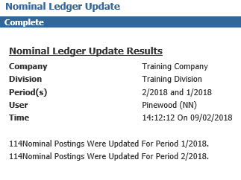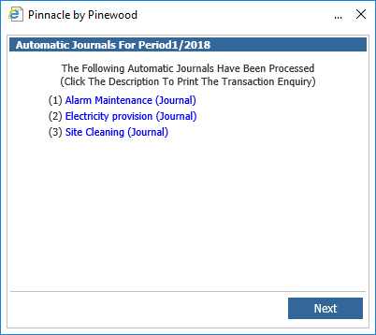

Click ‘Continue’ to complete the process.